**FORMAT TO REPORT YOUR ADVANCED JAVA PROGRAMMING PROJECTS**

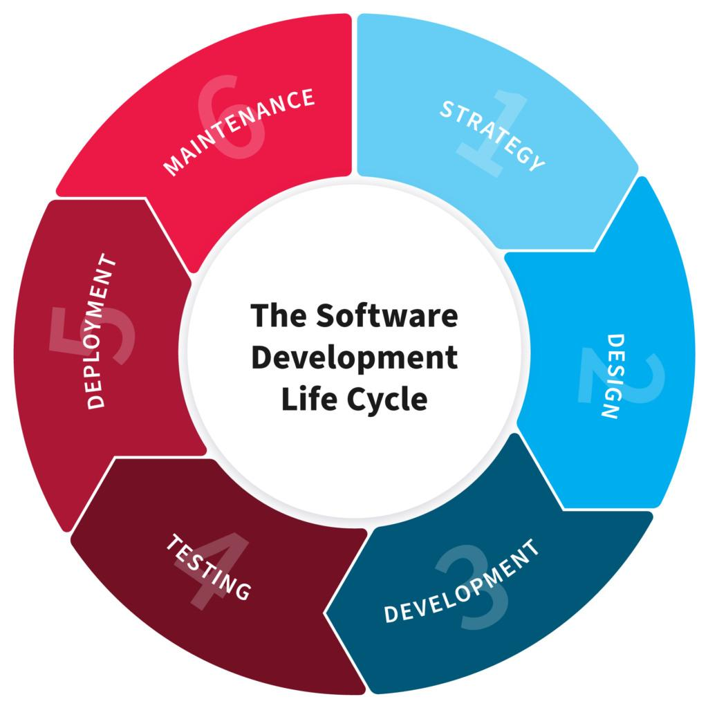

**NB: EVERY STUDENT HAS TO PRODUCE THIS DOC:**

**NAME:** MUKESHIMANA Honorine

**REG NO:** 221002626

**CLASS NO:** 49

**PROJECT NAME:** computer based census management system

**1. PLANNING**

*“In this Section, Students, have to define the system (your projects) goals and objectives and the problems the future system needs to solve.”*

**Introduction**

Computer based census management system is a computer applicationwhich is designed to:

* Undertake the periodic enumeration of the nation’s population through  
  census, sample surveys, etc.
* To establish and maintain the machinery for continuous and universal  
  registration of births and deaths.
* To reach and monitor national population polity and set up national population  
  information data bank.

Considering, in Rwanda the number of people entering the country has been very high compared to other years

**Goal and objectives**

The objectives of this **APPLICATION** are summarized as follows:

* To develop computerized software that automatically stores and retrieves all  
  information on human population.
* To develop a reliable system that could be used in collecting data/information  
  on human population.
* To develop a system that will support direct access to the specific and required  
  information

**Statement of Problem**

There are many problems affecting the National Population Commission from  
maintaining a steady reliable figures and estimates. These are the more reasons, why  
the our team embarked on this research:

* inadequate manpower
* lack of equipment
* poor organisation
* unstable polity
* manual bulk carrying of data

**2. Design**

*“In this Section, students needs to elaborate how the system will work, focusing on software design and how it works with the technical and functional requirements of the system. Depicts also how your team defined how users will interact with the software.”*

**2.1 Users of the System**

* censor
* Admin
* government
* Jobseeker

**2.2. Specific Requirements**

**Functional and Non Functional Requirements**

**Functional Requirements:**

* Complete overview of the population.
* Secure registration of all users
* Complete Search of the entire citizen no for easy access.
* Local language support at user-interface and database-level.
* Facilitate communication between user, experts and general public through comment

**Non-Functional Requirements:**

* availability
* Better component design to get better performance at peak time
* Flexible service based architecture will be highly desirable for future extension.

**2.3 DESIGN**

*System work:* It focuses on the registration, retrieval and management of information about individuals in the society. And population or the user can participate for our system in requesting same information about him/her. Before to access the information about our system you may login first if you are admin get admin page else user go to page of registration and other menu.

From Above, as team we descried the main input , process and output of our project:

**2.3.1 DFD LEVEL 0**

1. Login 3. Forward to the adimn

**Computer based census management system**

ADMIN

USERS

1. Request data details

response

5. response

**2.3.2 USE CASE DIAGRAM**

COMPUTER BASED ON CENSUS MANAGEMENT SYSTEM

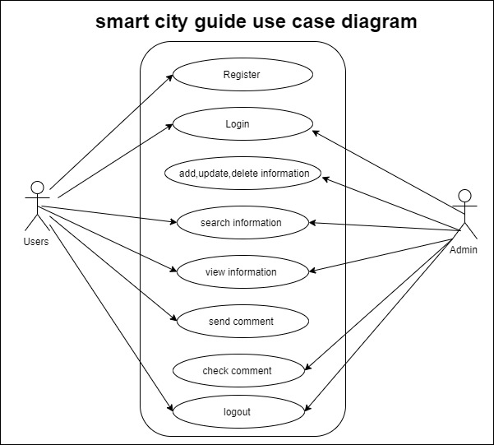

**3. DEVELOPMENT**

*“In this Section, Students need to elaborate how they build the entire system( Front end- back end technologies), chosen libraries, platforms, storage and databases, adopted technologies, etc...”*

* We developed the system backend and frontend parts using java programming language as well as NetBeans IDE and xampp for database.
* For frontend parts, we used swing controls generated from NetBeans to create forms, buttons, labels as well as user interface as whole.
* We used MySQL as database management system to hold backend data.
* We create interactions between user interface components such as forms and buttons using java programming language syntaxes.
* We used com.mysql.jdbc_5.1.5.jar as library handling MYSQL connection with the system and also absolute layout.jar.

**4. TESTING**

*“In this Section, Students to show the way this stage was conducted. Ensuring that everything works as expected. Which defects and bugs you found, and how did you fixed them to ensure that the product meets the original specifications.”*

Test case :computer based on census management system

|  |  |  |  |  |  |  |  |  |
| --- | --- | --- | --- | --- | --- | --- | --- | --- |
| Sl. No | Test Case Name | Input | | Expected Output | | Actual Output | | Valid/Invalid |
| **1** | User name | Numbers like 123.. | | User name is notcorrect | | User name entered is invalid | | Invalid |
| User name | hono | | Username is correct | | Valid username | | valid |
| **2** | Admin name | numbers | Admin name isnot correct | | | Names entered is invalid | | Invalid |
| Admin name | ndatimana | Admin is correct | | | Names entered is valid | | Valid |
| 3 | Username , admin name and password | hono has registered as  User | User home page should be opened | | If went admin home page invalid | | Invalid | | |
| ndatimana has registered as admin | admin Home page must be displayed | | If went to admin home page | | Valid | | |

**5. DEPLOYMENT**

*“In this Section, Students have to describe how, installation, testing, deployment, and performance monitoring were conducted in their own respective laptop or desktop. “*

* I Installed MYSQL as database management system using XAMPP software.
* I Downloaded and configuredcom.mysql.jdbc_5.1.5.jar as library handling MYSQL connection.
* Use portable storage device to transfer project from development computer to the user who want to explore application.
* I tested my population’s data by entering wrong data to see if it won’t work and by entering right data to see if it will work well.
* Take project has been zipped, import in the netbeans app you installed before.
* And then, import the database in the xampp software
* After testing it I Run project file and start using the system